American Norms vs. American Dream
Student loan debt is the new normal for any American college graduate. But they can be deferred, right? Sure, with a high interest rate tacked into the fine print. But the monthly payment can be really low, right? Absolutely, if you want to have the payment forever and have your debt-to-income ratio so off balance you can’t get a home loan or any other kind of loan. But these are the things that no one talks about until the ink is dry on the loan agreement. So, there’s no hope of owning a home? Of course there’s hope for owning a home! And Julie Zelnick’s story is proof that although student loans are still a risky venture, they should not keep hardworking college graduates trying to get on their feet from owning their own home.
Julie rented an apartment for seven years. In 2012, her cousin told her about Universal Housing Development Corporation and different programs they offer to low-income households. Frustrated with conventional lenders, Julie decided to call the office. She got in touch with Beverly Massey, Programs Manager, who told her about UHDC Construction, which works with low-income households that aren’t quite eligible for Self-Help, build their own brand new, energy efficient home. She told Beverly about her issues with student loan debt, sure that this would disqualify her from any program, but she was pleasantly surprised when Beverly referred her to UHDC’s Executive Director Patricia Atkinson to discuss the particulars of the program. An even better surprise…she was approved!
Building on her 3 bedroom, 2 bath home began in January 2013 at Ashbrook Estates in Russellville. After over a year of construction, Julie met with Pat on July 28, 2014 at David Eddy’s office to sign the closing papers on her new home. “My student loan payment is higher than my house payment,” Julie said with a smile upon learning her monthly payment at closing. Her story just goes to show that student loan debt, while it may be the new “norm” in America, doesn’t have to keep anyone from the original American dream: homeownership!

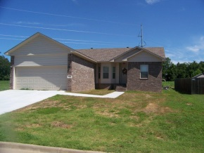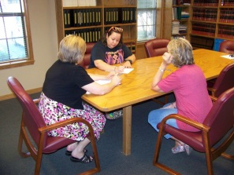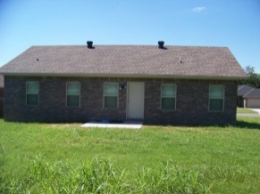

Left: Zelnick house, front view; Middle: (l to r) Julie Zelnick, Shawn Blevins (David Eddy’s Office), and UHDC ED Patricia Atkinson signing the closing papers; Right: Zelnick house, back view

